Tale App: A Social Media Platform for Interactive Storytelling
Team Members

Kummari Kavya Sri
Computer Science and Engineering
Vardhaman College of Engineering
Hyderabad, India
kavyasri4741@gmail.com
Danam Archana
Computer Science and Engineering
Vardhaman College of Engineering
Hyderabad, India
archanadanam@gmail.com
Angothu Adhisheshu
Computer Science and Engineering
Vardhaman College of Engineering
Hyderabad, India
angothuadhisheshu@gmail.com
Mohammed Musthabeen Ahmed
Computer Science and Engineering
Vardhaman College of Engineering
Hyderabad, India
mdmusthabeen@gmail.com
Abstract
Tale App is an interactive social media platform designed for storytelling, meme creation, and multimedia sharing. Users can write, listen to, and share stories while engaging with a global community. The app integrates features such as content discovery, AI-based recommendations, and collaboration tools. It also supports audio and video content, enhancing the storytelling experience.
Objective
- Encourage Creativity: Provide a space where users can create and share stories.
- Interactive Engagement: Enable user interaction through likes, comments, and shares.
- Multimedia Integration: Allow users to add audio, video, and images to stories.
- Community Building: Connect users through following, messaging, and collaborative content creation.
- Kid-Friendly Content: Introduce rhymes and games for young learners.
Process of Tale App
- User Registration & Login
  - Secure sign-up and authentication.
- Story Creation
  - Users write and format stories.
  - Option to add audio narration.
- Content Sharing
  - Stories can be shared publicly or privately.
- Engagement Features
  - Like, comment, and share stories.
  - Follow favorite authors.
- Kids Section
  - Rhymes and interactive games for children.
- Social Media Integration
  - Option to share stories on other platforms.
Problem Statement
- Lack of interactive platforms that merge storytelling and social media features.
- Difficulty in discovering creative content and engaging with it effectively.
- Limited options for multimedia integration in storytelling.
Problem Solution
- AI-based recommendations for personalized content.
- Interactive multimedia support (text, audio, video, and images).
- Community-driven content creation, including co-authoring stories and collaborating on memes.
- Kid-friendly content with educational rhymes and games.
Flowchart
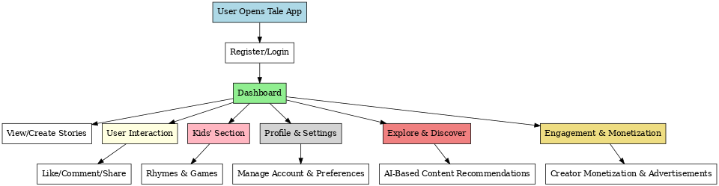

Tale App Flowchart Explanation
- User Entry
  - The user can either Register, Reset Password, or Login to access the app.
- Home Screen (After Login)
  - Once logged in, the user reaches the Home section.
- Main Features from Home
  - Memes: Users can create, share, and engage with meme content.
  - Story: Users can write, read, and interact with stories.
  - Singing: A section dedicated to audio-based content or singing-related activities.
  - Children Section: Includes rhymes, games, and educational content for kids.
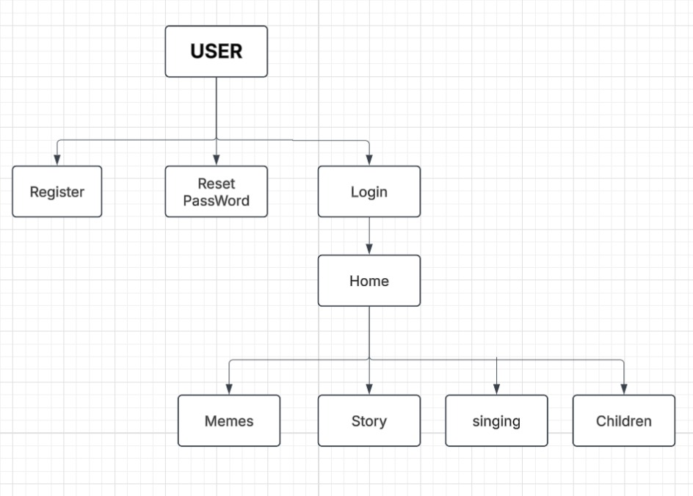
Introduction
Tale App is designed to revolutionize digital storytelling by integrating social networking features. It serves as a platform for users to express creativity through writing, audio, video, and memes while engaging with a vibrant community. The app's intuitive interface and AI-powered content recommendations enhance user experience and retention.
Future Updates
- Advanced AI Recommendations for story discovery.
- Animated Storytelling & AR/VR Support for immersive experiences.
- Monetization for Creators through ads, tips, and premium content.
- Improved Collaboration Tools for co-authoring.
- More Social Features like direct messaging and groups.
Rhymes and Games for Kids
- Nursery Rhymes: Animated rhymes for early learning.
- Interactive Games: Educational storytelling games to enhance creativity.
- Voice Narration & AI Tutors for personalized learning.
Strategies to Attract Users
- Gamification: Reward system for engagement.
- Personalized Recommendations: AI-driven content suggestions.
- Social Sharing Features: Seamless integration with platforms like Instagram and Facebook.
- User Challenges: Writing competitions and meme contests.
- Freemium Model: Free basic features with premium add-ons.
Monetization strategies:
1. Subscription Model
- Offer premium content such as exclusive stories, audiobooks, or AI-generated recommendations.
- Provide ad-free experiences for paid subscribers.
- Implement tiered pricing for different levels of access.
2. Advertisements
- Display banner ads, video ads, and interstitial ads within the app.
- Partner with brands for sponsored content and promotions.
- Implement native ads within stories or rhymes.
3. In-App Purchases
- Sell exclusive rhymes, story collections, and premium games.
- Offer custom avatars, themes, or stickers for kids' interaction.
- Allow users to purchase story templates or editing tools.
4. Creator Monetization
- Enable story creators to sell their content on the platform.
- Introduce a revenue-sharing model where creators earn from paid content.
- Provide crowdfunding options where users can support their favorite storytellers.
5. AI-Based Personalized Recommendations
- Charge users for AI-driven storytelling features (e.g., personalized bedtime stories).
- Provide content curation services for schools, parents, or educational institutions.
6. Partnerships & Licensing
- Collaborate with educational platforms, publishers, and children’s content creators.
- License content to schools and educational apps.
- Sell white-label versions of the Tale App to businesses.
7. Events & Live Sessions
- Host live storytelling sessions with authors and educators.
- Sell tickets for premium interactive storytelling events.
- Conduct kids’ competitions or talent shows with entry fees.
Tale App is set to redefine interactive storytelling by merging social media and creative content creation into a single dynamic platform.

